Recipe/Ingredient Information System Planning Doc
Amy Rittenhouse-Ramizi, Lucas Rich, Ty Disbro, Evan Cutler
TABLE OF CONTENTS
- System Description – Page 2
- Functional and Non-Functional Requirements - Page 4-8
- Business Benefits – Page 9
- Data Flow Diagrams – Page 10
- Data Dictionary – Page 11-12
- Entity Relationship Diagram – Page 13
- Feasibility and Risk Analysis – Page 14-16
- Project Schedule – Page 17-23
- Project Budget – Page 24
- User Interface Screens and Reports – Page 25-28
- Dialogue Diagrams – Page 29
- Stored Data – Page 30
- System Controls – Page 31
- Module Test Plans – Page 32

System Description

Overview
The Recipe Share app is a cross-platform mobile and web application designed to help users manage personal recipe collections and share them with friends and family. It combines recipe organization tools with social features such as messaging and recipe sharing. Users will be able to import recipes from websites or by uploading a picture of handwritten or printed recipes.
The application follows a freemium model where users are allowed to store and manage up to 10 recipes free of charge, after which they will be prompted to subscribe to a premium plan that unlocks unlimited recipe storage and additional features.
This project aims to provide a scalable, user-friendly solution that encourages both casual home cooks and food enthusiasts to organize and share their favorite meals. This app plans to help users store recipes in a viewable format, track items needed for recipes, and quickly send recipes to friends all in one app.

Project Scope
Project Scope Statement: Project encompasses the design, development, testing, and deployment of a mobile app to manage, store, and share cooking recipes. Core features include recipe creation, folder management, user sharing, and messaging.
In Scope
- User authentication and profile management
- Recipe CRUD (Create, Read, Update, Delete)
- Folder creation and management
- Recipe and folder sharing with friends
- Direct messaging between users
- Recipe importing (via website or photo upload)
- Freemium logic (10 free recipes then paid subscription)
- Subscription system with billing and payment plan management
- Basic admin dashboard for monitoring
- Testing, bug fixing, and deployment
Out of Scope:
- AI based recipe suggestions (future enhancement)
- Web version of the app (version 2)
- Meal planning, calendar, or grocery list features
Assumptions:
- Users will have access to modern web browsers compatible with the system.
- All required credentials will be provided to employees sometime prior to implementation.
- Third-party services such as cloud-based services will remain up and running throughout development.
Constraints:
- Budgeting could be a problem, needing to pay a monthly fee to other companies to use their third-party services.
- Timeline might be an issue, as if we run into a roadblock, that could mean we have to push back the release of the app.
- UI is limited to ensure mobile usage is available.

Functional Requirements
Registration/Log in (Email/password, Social Log In Options: Apple, Google, etc.):
- Users should be able to register for an account using email and password.
- Client → Server Flow
- User submits registration or login form from the UI.
- Users send credentials or OAuth tokens to the Authentication Service API.
- For OAuth logins (Google/Apple), client receives authorization token from the provider and passes it to the server for verification.
- Server returns a JWT/Session token for authenticated access
- Users can log in through platforms such as Google and Apple.
- Provides email confirmation during registration for account verification.
- APIs
- POST /auth/register
- POST /auth/login
- POST /auth/oauth/google
- POST /auth/oauth/apple
- POST /auth/verify-email
- POST /auth/reset-password

- Databases
- Users Table (id, email, password_hash, auth_provider, created_at)
- Sessions/JWT Blacklist (optional)
- Email Verifications Table
- Additional Behavior
- System sends verification emails using an Email Service (SMTP or transactional email API).
Recipe Creation and Upload:
- Users should be able to create/upload recipes directly through the website.
- Client → Server Flow
- User fills in recipe form (title, steps, ingredients, photos).
- Client uploads photos to the File Storage Service (e.g., S3/GCS) via signed URLs.
- Metadata (title, steps, ingredient list, image URLs) sent to Recipe Service API.
- Each recipe should include the following required fields: Title, Ingredients, Preparation Steps, and Photos.
- APIs
  - POST /recipes
  - PUT /recipes/{id}
  - DELETE /recipes/{id}
  - GET /recipes/{id}
- Databases
- Recipes Table (id, user_id, title, ingredients JSON, steps, created_at)RecipePhotos Table (recipe_id, photo_url)
- Tags or Metadata Tables (optional)
- File Storage
- Cloud storage bucket for images.
Folder Management:
- Users can create, rename, and delete folders to organize their recipes effectively.
- Users create folders to organize recipes.
- Drag-and-drop or UI actions send operations to server.
- APIs
- POST /folders
- PUT /folders/{id}
- DELETE /folders/{id}
- POST /folders/{id}/recipes
- Databases
- Folders Table (id, user_id, name)
- FolderRecipe Join Table (folder_id, recipe_id)
Recipe Sharing:
- Users should be able to share recipes with friends through in-app sharing and public link sharing.
Messaging:
- Users can send and receive text-only messages with friends on the platform.
- Client → Server Flow
- Client sends message to server over REST or WebSocket.
- Server stores messages and pushes real-time updates to recipients.
- APIs
- GET /messages/{conversation_id}
- POST /messages
- Realtime: Optional WebSocket endpoint /ws/messages
- Databases
- Conversations Table (id, participant IDs)
- Messages Table (id, conversation_id, sender_id, text, timestamp)
Notifications (Email confirmation/SMS notification):
- This system sends email confirmations for registration and password resets.
- May receive SMS notifications for important updates or account activities.
- Server Workflow
- Auth Service triggers emails for verification and password resets.
- Notification Service triggers SMS for account activity.
- APIs
- Internal microservice calls:
- POST /notifications/email
- POST /notifications/sms
- Integrations
- Email provider: SendGrid, SES, Mailgun.
- SMS provider: Twilio, Nexmo.
Import Recipe Data (OCR feature)
- Users can upload an image containing a recipe
- Uses OCR to extract text such as ingredients and preparation steps
- Client → Server Flow
- User uploads an image.
- Server stores the image and processes with an OCR engine.
- Extracted text is sent back to the client for editing.
- APIs
- POST /OCR/upload
- GET /OCR/result/{job_id}
- Services
- OCR Engine: Tesseract, Google Vision API, AWS Textract
- Databases
- OCR Jobs Table (job_id, user_id, image_url, extracted_text)
Recipe Limit:
- Free Users: Can save up to 10 saved recipes
- Premium Subscription: Unlimited recipe storage.
- Server Behavior
- On every recipe creation request, Recipe Service checks the user’s subscription tier.
- APIs
- GET /user/subscription
- POST /subscriptions/upgrade
- Databases
- Subscriptions Table (user_id, plan_type, renewal_date)
- Payment Transactions Table
This provides an upgrade option for users to switch to a premium plan.
Non-Functional Requirements
- Technical: Can run on low-end devices that can access the internet. Supports IOS, Android, Linux, and Windows. Should be designed to scale continuously to support user base growth.
- Performance: Supports 500+ concurrent users without degrading in performance. Responses should be almost instantaneous.
- Usability: Creates a user-friendly UI, mobile-first interface with minimal steps.
- Reliability: Maintains 99% uptime with strong cloud infrastructure.
- Security: Ensures secure user data storage and safe payment processing for premium subscriptions. If problems arise, ensure rollback data is on hand.
- Storage: Has enough storage capacity to hold unlimited recipes and user data

Business Benefits
The Recipe Share app provides several key business benefits. The freemium model allows the app to attract a large base of users drawn in by being able to run what is essentially a permanent free trial. While some users may be dissatisfied with the freemium model, many users will buy the premium subscription after testing the waters and liking our product. If we have an initial 50,000 users at launch, and only 5% of those users buy the $5.99 premium subscription, the company will be earning roughly $6,000 a month from the start, and that number will only increase as time goes on.
Additionally, by adding a friend system, this will allow free marketing from our users by word of mouth. If 50% of our previous premium subscribers recommend it to two friends, this will give us an additional 1,000 users, which may not seem like much, but the numbers will add up as more people are both finding and recommending the app.

Data Flow Diagram
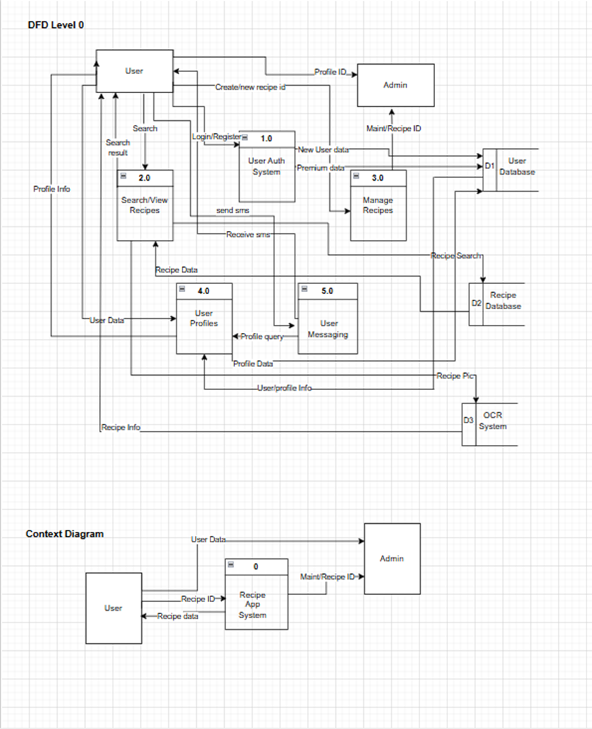
  - External entities: User Database, Admin, Recipe Database, OCR system
  - System: Recipe App System processes input and coordinates data flow.

Data Dictionary
Category | Name | Type | Definition/Description
Data Element | User ID | GUID/Int | Users’ unique identifier
 | Username | String | Login name/credentials
 | Password | String- Encrypted | Encrypted authentication String
 | Email | String | Users contact email
 | Phone Number | String | Users number for SMS
 | Profile Info | Text | User profile details (bio, etc)
 | Recipe ID | GUID/Int | Unique Recipe identifier
 | Recipe Title | String | Recipe Name
 | Ingredients List | JSON Array/Text | List of required ingredients
 | Instructions | Text | Recipe preparation steps
 | Recipe Category | String (ENUM) | Categories (Main, appetizers, desserts, seafood, vegan, etc.)
 | Recipe Image | Binary/Image File | Image uploaded by user
 | Recipe Search Queary | String | Keywords used to search recipes
 | Premium Status | Boolean | Premium user indicator (Y/N)
 | Admin ID | GUID/Int | Unique Admin identifier
 | Profile Queary | String | Request for user profile info
 | Message ID | GUID/Int | Unique identifier for user message
 | Message Content | Text | Actual text of message
 | OCR extracted Text | Text | Text extracted from image using OCR
 | Maint/Recipe ID | GUID/Int | ID used by admin to update recipes/app
Data Flow | User Data |  | Contains-user ID, Username, password, email, phone #, Profile Info, premium status
 | Recipe Data |  | Contains- Recipe ID, Title, Ingredients, Instructions, Category, Image, OCR extracted text
 | Profile Data |  | User ID, Username, Profile Info, User Recipes
 | Search Queary |  | Contains- search query + user ID
 | Messaging |  | Contains- Message ID, Sender ID, Receiver ID, Message Content, Timestamp
 | Admin Maint. |  | Contains- Admin ID, Maint/Recipe ID, update actions
 | OCR Input |  | Contains- Imade, User ID
Data Store | D1-User Database |  | Stores all user data, profiles, credentials, premium info
 | D2-Recipe Database |  | Stores all recipes, images, OCR text, categories, search metadata
 | D3-OCR System |  | Stores OCR processing rules and extracted text
Process | 1.0 User Auth System |  | Manages login, registration, authentication
 | 2.0 Search/View Recipes |  | Handles recipe search and displays results
 | 3.0 Manage Recipes |  | Creates, edits, deletes recipes
 | 4.0 User Profiles |  | Manages and displays user profile info
 | 5.0 User Messaging |  | Sends and receives messages between users

Entity Relationship Diagram
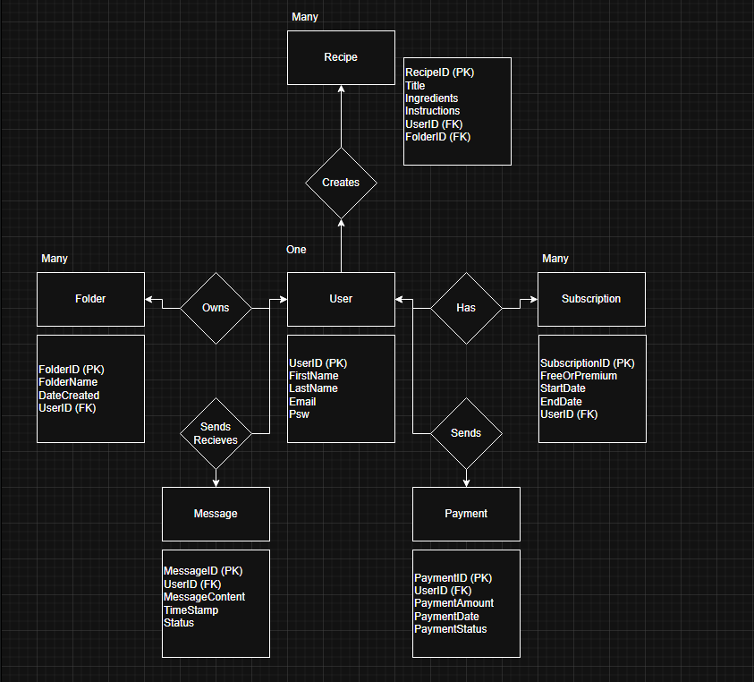

Feasibility Assessment
- Economic
- Increase premium subscriptions by 25% through ads and user benefits (i.e. get discount on premium subscription when you share with 5 friends).
- Costs:
- Development: $27,000 (6 months, team salaries)
- Infrastructure: $500 Cloud Computing
- Training & Support: $4,500 initially
- Annual maintenance cost: $13,500 - $16,000
- Expected ROI = +20%
- ROI expected to breakeven at the 2-year mark
- Technical
- Compatibility with existing systems and software. Has a website that is accessible from anywhere with a phone, laptop, or desktop.
- App relies on third-party services such as payment processors and cloud hosting.
- Requirements:
- Requires a payment gateway to be implemented.
- Will require features to be unlocked if subscription is paid in full.
- Users must be able to sign up and get into the app smoothly, as well as manage their recipes and send them to other users smoothly.
- Risks: Data migration errors, integration latency
- Mitigation: Scheduled maintenance at a time when users are not active, where the site goes down temporarily while we update it. If something goes wrong during maintenance, have a failsafe that will roll back data to a previous point.
- Operational
- Requires routine maintenance to ensure both app and website run smoothly.
- Staff training to run the app is required.
- Risks: Users struggle with design. Potential data loss.
- Mitigation: Test out initial UI designs with focus group. Listen to user feedback and improve it. Add a rollback system to ensure data is not entirely lost.
- Legal/Contractual
- Compliance with data protection laws and payment processors.
- Holding sensitive info like card payment methods will require security to ensure no data is leaked. (PayPal option)
- Vendor contracts for maintenance fees and software procurement will be necessary.
- Risks: Potential data breaches
- Mitigation: Encrypt data, regularly update security.
- Political
- Stakeholders will have a stake in what is implemented, and staff will be critical for successful implementation.
- Requires stakeholder buy-in for recurring costs.
- Alignment meetings are necessary to ensure stakeholders understand our app’s purpose and to ensure they know what they will be funding.
- Risks: Potential resistance from staff who are used to existing processes.
- Mitigation: Regular communication. Provide training sessions to ensure staff know how to handle issues.
- Schedule, Timeline, and Resources
- Timeline: Estimated Project Duration: 8 months.
- Resources: 1 PM, 1 Developer, 1 QA, 1 Business Analyst
- Risks: Staff availability conflicts
- Mitigation: Flexible work schedule.

Project Schedule
Work Breakdown Structure (WBS)
- Initiation
- Planning
- Design
- Development
- Testing
- Deployment
- Maintenance & Support
Phase 1: Initiation (1 Weeks)
Task ID | Task Description | Duration | Dependencies | Resources | Deliverables | Milestone
1.1 | Identify Stakeholders | 9/16/25 | None | PM, SA | Stakeholder list | Stakeholders identified
1.2 | Project Synopsis | 9/16/25 | 1.1 | PM, SA | Rough Outline of Work to be Done | Outline
1.3 | Kickoff meeting | 9/16/25 | 1.3 | PM, Team | Meeting Minutes | Project Kickoff
Phase 2: Planning (5 Weeks)
Task ID | Task Description | Duration | Dependencies | Resources | Deliverables | Milestone
2.1 | Gather detailed requirements | 9/23/25 | 1.3 | PM, Team | Requirements Specification Doc | Requirements baseline
2.2 | Conduct Feasibility Analysis | 9/23/25  -  10/14/25 | 2.1 | PM, SA | Feasibility Report | Feasibility Approved
2.3 | Develop System Architecture Design | 9/23/25  -  10/21/25 | 2.1 | DT | Architecture Design | Architecture Approved
2.4 | Create Project Schedule | 9/23/25  -  10/7/25 | 2.1 | PM | Detailed project Plan | Schedule Finalized
Phase 3: Design (TBD Weeks)
Task ID | Task Description | Duration | Dependencies | Resources | Deliverables | Milestone
3.1 | Context Diagram | 10/28/25 | 2.3 | PM | Data Flow Diagram Mockup | DFD Approved
3.2 | UI Prototyping | 2/15/26  -  3/4/26 | 2.1 | UI Designer | UI Mockups | UI Approved
3.3 | Database Schema Design | 2/15/26  -  3/4/26 | 2.3 | DT | Database Documentation | Schema finalized
3.4 | API design and Documentation | 2/15/26  -  3/4/26 | 2.3 | DT | API Spec Document | API Specs Approved

Phase 4: Development (TBD Weeks)
Task ID | Task Description | Duration | Dependencies | Resources | Deliverables | Milestone
4.1 | Backend Core Functionality Development | 3/5/26  -  3/19/26 | 3.3 | DT | API Endpoints | Backend Core Completed
4.2 | Frontend Patient Portal Development | 3/5/26  -  3/19/26 | 3.2, 3.4 | DT | Patient UI Modules | Frontend Patient UI Complete
4.3 | Frontend Admin Dashboard Development | 3/5/26  -  3/19/26 | 3.2 | DT | Admin UI Modules | Admin UI Complete
4.4 | Integration of frontend & Backend | 3/20/26  -  3/26/26 | 4.1, 4.2, 4.3 | DT | Integrated System | Integration Complete
4.5 | Implement Payment System | 3/27/26  -  4/4/26 | 4.4 | DT | Payment Module | Payment System Implemented
Phase 5: Testing (TBD Weeks)
Task ID | Task Description | Duration | Dependencies | Resources | Deliverables | Milestone
5.1 | Unit Testing (Frontend & Backend) | 4/5/26  -  4/11/26 | 4.4 | QA, DT | Unit Test Reports | Unit Tests Passed
5.2 | Integration & System Testing | 4/12/26  -  4/18/26 | 5.1 | QA | Integration Test Reports | Integration Tests Passed
5.3 | User Acceptance Testing (UAT) | 4/19/26  -  4/25/26 | 5.2 | QA, SA, Users | UAT Feedback & Sign-Off | UAT Approved
5.4 | Performance & Security Testing | 4/26/26  -  5/4/26 | 5.2 | QA, Security Team | Load and Vulnerability Reports | Performance & Security Approved
Phase 6: Deployment (TBD Weeks)
Task ID | Task Description | Duration | Dependencies | Resources | Deliverables | Milestone
6.1 | Prepare Production Environment | 5/5/26  -  5/11/26 | 5.3, 5.4 | DT | Production Ready Infra | Prod Infra Ready
6.2 | Data Migration & Synchronization | 5/5/26  -  5/18/26 | 6.1 | DT | Data Migrated | Data Migration Complete
6.3 | Production Deployment & Smoke Testing | 5/5/26  -  5/18/26 | 6.1 | DT, QA | Live System Deployed | Production Deployment Done
6.4 | Staff Training & User Onboarding | 5/5/26  -  5/18/26 | 6.1 | SA, PM | Training Materials & Sessions | Users Trained
Phase 7: Maintenance & Support (Ongoing)
Task ID | Task Description | Duration | Dependencies | Resources | Deliverables | Milestone
7.1 | Monitor System Performance & Uptime | Ongoing | 6.3 | DT | Monitoring Reports | SLA Targets Met
7.2 | Bug Fixes & Patch Releases | Ongoing | 7.1 | DT | Issue Fixes, Release Notes | Continuous Improvements
7.3 | User Feedback Collection & Enhancements | Quarterly | 7.2 | SA, PM | Feedback Reports | Regular Updates Planned
7.4 | Security Audits and Compliance Checks | Semi-Annual | 7.1 | Security Team | Compliance Reports | Compliance Maintained

Preliminary Schedule
Phase | Duration | Weeks | Approx. Calendar Range | Milestones Reached
Initiation | 1 Weeks | Week 1 | 9/16/25 - 9/22/25 | Stakeholders identified, Outline, Project Kickoff
Planning | 2 Weeks | Week 2-3 | 9/23/25 - 10/6/25 | Requirements baseline, Feasibility Approved, Architecture Approved,  Schedule Finalized
Design | 3 Weeks | Week 4-6 | 10/7/25 - 10/28/25 | DFD Approved, UI Approved, Schema finalized, API Specs Approved
Development | 5 weeks | Week 7-10 | 3/5/26 - 4/4/26 | Backend Core Completed, Frontend Patient UI Complete, Admin UI Complete, Integration Complete, Payment System Implemented
Testing | 5 weeks | Week 11-15 | 4/5/26 - 5/4/26 | Unit Tests Passed, Integration Tests Passed, UAT Approved, Performance & Security Approved
Deployment | 3 Weeks | Week 16-18 | 5/5/26 - 5/18/26 | Prod Infra Ready, Data Migration Complete, Production Deployment Done, Users Trained
Maintenance | Indefinite | Week 19+ | 5/19/26 - Indefinite | SLA Targets Met, Continuous Improvements, Regular Updates Planned, Compliance  Maintained

Gantt Chart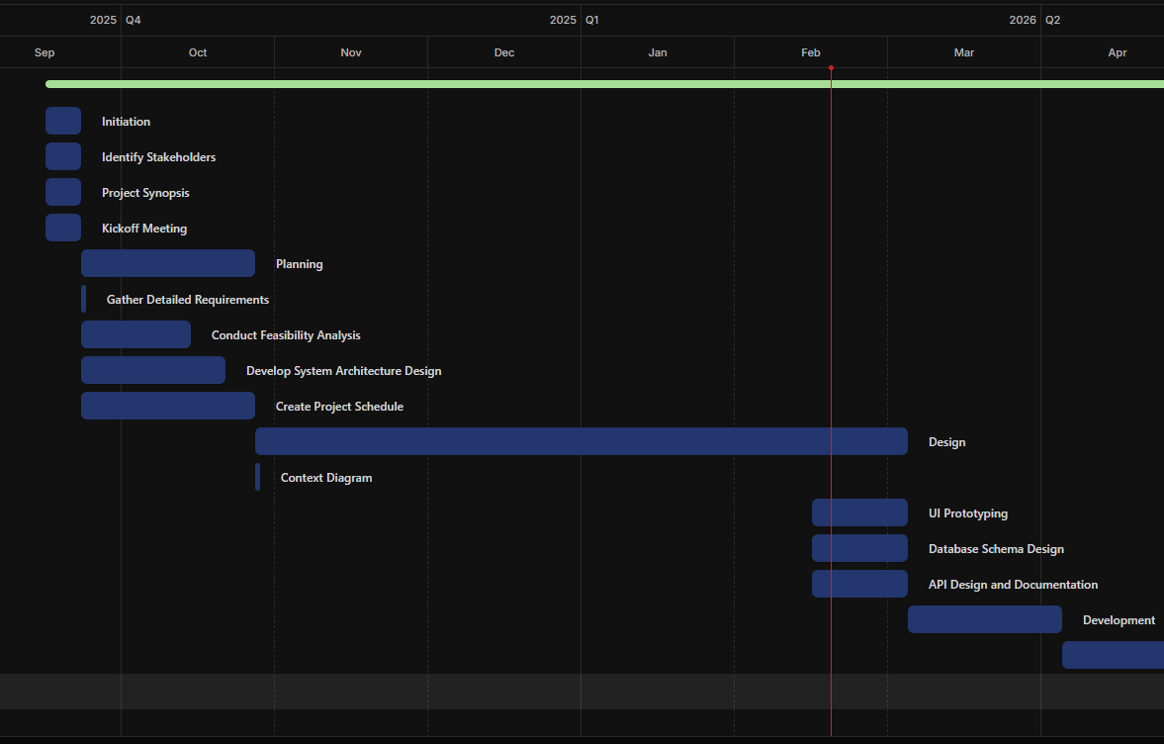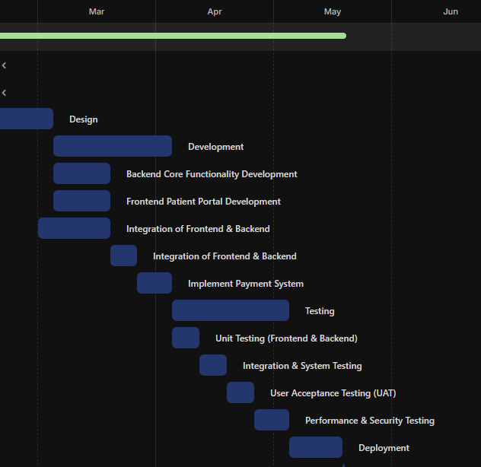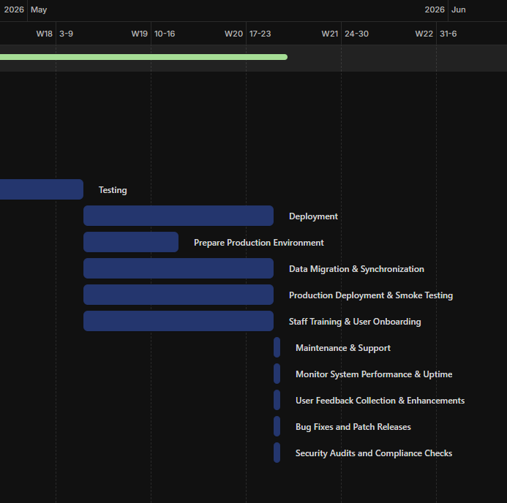

Project Budget
The project requires an initial fee of $5,000 to make sure staff are properly trained to handle customer support and development, as well as the cloud infrastructure for storing customer data. After the initial cost, it’ll cost $36,000 for team salaries for a 6-month duration, costing $216,000, where it will then need an annual maintenance cost of roughly $16,000 to ensure the platform has proper upkeep.

User Interface Screens and Reports
The Interface will be designed to be simple, visual, and easy to navigate for users of all skill levels. It will focus on searching, sharing, and managing recipes with friend-to-friend communication.
User Interface Screens
Login and Authorization Screen (Process 1.0 - User Authorization)
- Allows users to log in or register using email/password or third-party accounts (Apple/Google)
- Credentials are validated by the User Authentication System
- Password reset options and SMS verification options available
- Successful authorization gives access to system features (standard/premium)
- User account data is stored in D1-User Database
Home/Search Recipes Screen (Process 2.0 - Search/View Recipes)
  - Search bar for recipe name or ingredients
  - Filter for category, difficulty, and dietary preference
  - List or grid display of recipe titles, images, and descriptions
  - Selecting a recipe sends a Recipe ID to the system and retrieves recipe data from D2 - Recipe Database
Recipe Detail Screen
- Displays recipe information including:
  - Ingredients
  - Instructions
  - Images
- Recipe data retrieved from D2- Recipe Database
- Recipe images may be processed by D3 – OCR System to extract text
Submit/Manage Recipes Screen (Process 3.0 - Manage Recipes)
- Feature for adding, editing, and updating Recipes
- Upload picture feature
- Recipe images sent to D3 – OCR System for text extraction
- Updated recipes are stored in D2 – Recipe Database
User Profile Screen (Process 4.0 - User Profiles)
- Displays and allows editing of user profile information
- Display user-submitted and saved recipes
- Profile data stored and retrieved from D1 – User Database
Messaging Screen (Process 5.0 - User Messaging)
- Interface for sending and receiving messages between users
- Interface for sending and accepting friend requests
- SMS notifications supported through the User Authorization System
- Messaging activity linked to user profile data
- Profile information retrieved from User Profiles (4.0)
Reports
User Profile Reports
- User activity and authorization logs
- Saved or created recipes
- Total number of registered users (administrative view)
Recipe detail reports
- Recipe name
- Ingredients
- Instructions
- Uploaded images
- Recipe ID
Search Results Reports
- List of matching recipes
- Filtered results
Recipe Submission and Management Reports
- Administrative Maintenance summaries
- List of added/updated/deleted recipes
- Recipe database updates
Messaging Activity Report
- System messaging and usage summaries
- Sent/Received logs
- Timestamps
Features
- Secure user authorization (1.0)
- Recipe searching and viewing
- Recipe submission and management
- OCR-based recipe txt extraction
- User profile management
- SMS notification and messaging
- Administrative monitoring and maintenance

Dialogue Diagram
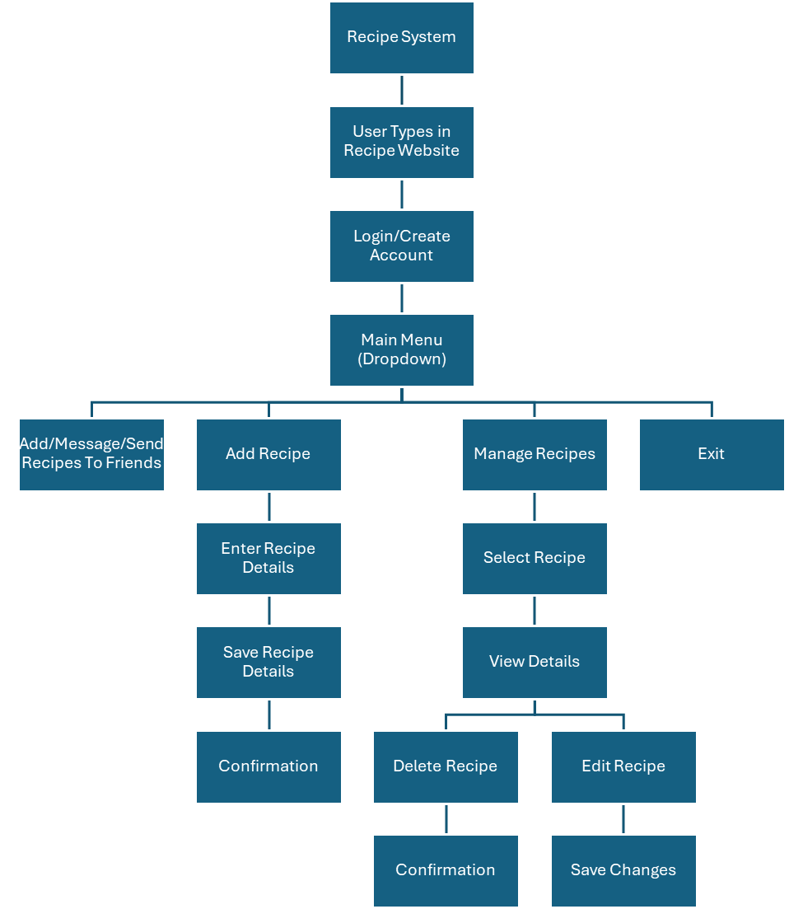

Stored Data
All data for the Recipe Share application will be stored in structured relational tables within a centralized cloud-based database management system. The system will organize data into separate but related tables, including Users, Recipes, Ingredients, Categories, Saved Recipes (Favorites), Friends, Messages, and Payments. Each table will contain a primary key for unique identification, and relationships between tables will be enforced using foreign keys to maintain data integrity and support many-to-many associations. The database will reside in a secure, centralized cloud environment. Hosting the database in the cloud ensures scalability as user demand increases, high availability, automated backups, disaster recovery capabilities, and secure encrypted access.

Identify System Controls
Security Controls:
- Users will authenticate using secure login credentials and passwords will be stored in encrypted form
- Access controls will allow users to modify their own saved recipes
- Shared recipes can be viewed only by authorized recipients (users’ friends)
- Sensitive data will be encrypted during storage and transmission

Data Integrity Controls:
- Input validation will ensure recipe data (ingredients, quantities, and instructions) are correct and in the right format
- Sharing permissions will be stored to prevent unauthorized edits to shared recipes (user will have control over permissions)
- Automatic saving, confirmation prompts, and regular backups will prevent any sort of data loss or corruption

Error Handling Controls:
- The system will display error messages when an invalid input, issue with sharing, or any sort of system error occurs.
- Error logging will record problems that are related to data accuracy or recipe sharing functions
- When an error occurs, the system will return the user to the main menu without losing data or crashing.

Acceptance Test Plans
Test Procedures
- Test Environment: Mirror production including database snapshot; separate from development.
- Test Data: New Account Profile; New Recipes Logged
Sample Test Cases:
Test Case ID | Description | Steps | Expected Result | Status Criteria
TC001 | Account creation | Sign up to site | Confirmation Email sent, new account created | Pass if Email is received and login successful
TC002 | Create a recipe and save it | Write down a recipe on the site, then save it to a folder. If no folder is available, have the option to create one. | Recipe is saved to folder | Pass if recipe is visible in folder
TC003 | Send a recipe to user | Select a recipe and send it to a different user | Separate account receives recipe and/or message | Pass if recipe is visible to another user
TC004 | Max out recipe slots | Create 10 recipes, and then try to create another one | Prompt asking to upgrade or delete a recipe | Pass if no more recipes can be created
TC005 | Test out Payment | Test if premium subscription can be bought and more recipes can be created | Given premium features | Pass if 11 or more recipes can be created

